

**Informatics Institute of Technology**

Department of Computing

(B.Sc.) in Computer Science

**Module: 4COSC011W**

**Web Design & Development**

**Module Leader: Ms. Janani Harishchandra**

|  |  |
| --- | --- |
| |  | | --- | |  | |

**COURSEWORK NO: 1**

**Date of Submission:** 24th of March 2020

**Student Role :** 2

**Student ID:** 2018199

**Student UoW ID:** w1761764

**Student First Name:** Radhika

**Student Surname:** Ranasinghe

Table of Contents

I. Introduction 3

II. Technical Discussion 3

II.I. Comments Form 3

II.II. Main Page, Navigation Bar and the Footer 6

II.III. The Individual Page (Recipes) 8

III. Discussion of UI and application of UX principles 10

III.I. Information Architecture 10

III.II. Color Balance/ Composition/ Graphics/ Consistency 12

III.III. Typography/ Consistency 15

III.IV. Gestalt Principles of Grouping 16

III.V. Accessibility (Graphics/ Forms) 17

III.VI. Error Prevention and Recovery 19

IV. Janet Regulations 22

V. Conclusion 22

VI. References 22

VII. Appendices 22

VII.I. Appendix A (Code) 22

Table of Figures

Figure 1: Screenshot of the index page 6

Figure 2: Screenshot of the icons grid element 6

Figure 3: Screenshot of the navigation bar 7

Figure 4: Screenshot of the Rate and Comment Modal 7

Figure 5: Screenshot of the footer 8

Figure 6: Screenshot of the Recipes (Cookies and Cream Cake) 8

Figure 7: Screenshot of the Recipes page (Apple Pie) 9

Figure 8: Screenshot of the Recipes page (Salted Caramel Cupcakes) 9

Figure 9: Screenshot of the Root Directory 10

Figure 10: Screenshot of the 'Active-Page' 11

Figure 11: Wireframe made for the Main Page 12

Figure 12: The Color Palette 13

Figure 13: The Logo of the enterprise 13

Figure 14: Contrast Ratio of the Colors Selected 14

Figure 15: Screenshot of the main page as an example for typography hierarchy 15

Figure 16: Screenshot of the Recipes Page (Evidence for Gestalt Grouping) 16

Figure 17: Screenshot of the Main Page (Evidence for Gestalt Grouping) 17

Figure 18: Screenshot of the Contact Page (Evidence for Gestalt Grouping) 17

Figure 19: Screenshot of the Main Page without Images 18

Figure 20: Screenshot of the Modal with placeholders in the form 19

Figure 21:Screenshot of the alert when rating is not checked 20

Figure 22: Screenshot of the alert when an invalid e-mail address is entered 20

# Introduction

The author and the team decided on staying ahead of the curve by selecting the one of the most contemporary trades in the market, The Food Industry. From the enormous industry it was confined to only bakery products. The website offers the users to purchase bakery products as well as a handful of the recipes of the products offered.

|  |  |  |  |
| --- | --- | --- | --- |
| Name | IIT Number | UoW Number | Student Role |
| Lysandra Manuelpillai | 2019496 | w1761425 | Student 1 |
| Radhika Ranasinghe | 2018199 | w1761764 | Student 2 |

# Technical Discussion

After the distribution of the student roles among the team members, the author decided on starting with the Comments Form which required a better perception than for other components of the student role.

## Comments Form

The requirement was to add a comment form with JavaScript validation for the e-mail address and neither the name nor the rating cannot be empty fields.

Author was able to achieve this requirement by initializing an HTML form and taking inputs from the user of the webpage that must be validated through JavaScript.

A snippet of the HTML code for the form is as follows:

1. <!---Comment Section Form--->
2. **<form** action="" name="commentSection"**>**
3. **<div** class="comment-fields"**>**
4. **<fieldset** class="inputFields"**>**
5. **<legend><label** for="name"**>**Name**</label></legend>**
6. **<input** type="text" name="name" id="name" placeholder="Name" class="comment"**>**
7. **</fieldset>**
8. **<fieldset** class="inputFields"**>**
9. **<legend><label** for="email"**>**Email**</label></legend>**
10. **<input** type="text" name="inputEmail" id="email" placeholder="E-mail" class="comment"**>**
11. **</fieldset>**
12. **<fieldset** class="inputFields"**>**
13. **<legend><label** for="comment"**>**Comments**</label></legend>**
14. **<textarea** id="comment" name="comment" placeholder="Enter you comment here" class="comment"/**>**
15. **</fieldset>**
16. **</div>**
17. <!--Rate Section-->
18. **<div** class="rate"**>**
19. **<input** type="radio" id="star5" name="rate" value="5"**/><label** for="star5" title="5 Stars"**>**★**</label>**
20. **<input** type="radio" id="star4" name="rate" value="4"**/><label** for="star4" title="4 Stars"**>**★**</label>**
21. **<input** type="radio" id="star3" name="rate" value="3"**/><label** for="star3" title="3 Stars"**>**★**</label>**
22. **<input** type="radio" id="star2" name="rate" value="2"**/><label** for="star2" title="2 Stars"**>**★**</label>**
23. **<input** type="radio" id="star1" name="rate" value="1"**/><label** for="star1" title="1 Star"**>**★**</label>**
24. **</div>**
25. <!--End of Rate Section-->
26. **<div** class="submit-button-container"**>**
27. **<a** href="" class="submit-comment" id="submitButton"**>**Submit**</a>**
28. **</div>**
29. **<div** id="modal-editor"**>**
30. Edited by: **<a** href="RadhikaRanasinghe.html"**>**Radhika Ranasinghe**</a>**
31. **</div>**
32. **</form>**
33. <!---End of the Comment Section Form--->

Some snippets of the JavaScript code for the comment form is as follows:

JavaScript function made for validation of the e-mail address. Through a regular expression the e-mail address is validated in parts. The username can only contain any upper- or lower-case letters including underscore, @ can be used only once while the domain follows. The domain can only consist 2 or 3 characters, but multiple number of domains can be used at the end of the string.

1. **function** ValidateEmail() {
2. **if** ((/^\w+([\.-]?\w+)*@\w+([\.-]?\w+)*(\.\w{2,3})+$/).test(email.value)){
3. correct_email = "yes"
4. }
5. **else**{
6. correct_email = "no"
7. }
8. }

JavaScript function made for getting the value of the radio buttons used for rating.

This function is used to get the input from the user for the rating with the use if radio buttons for star rating. Each radio button gives a value of stars from 1 – 5.

1. **function** check_rating(){
2. **if** (document.getElementById("star1").checked){
3. user_rating = "1 Star"
4. }
5. **else** **if** (document.getElementById("star2").checked){
6. user_rating = "2 Stars"
7. }
8. **else** **if** (document.getElementById("star3").checked){
9. user_rating = "3 Stars"
10. }
11. **else** **if** (document.getElementById("star4").checked){
12. user_rating = "4 Stars"
13. }
14. **else** **if** (document.getElementById("star5").checked){
15. user_rating = "5 Stars"
16. }
17. }

Through CSS the radio button was made invisible and only the star text is visible. When the mouse is hovered over the rating stars, the color changes before the preferred radio button is clicked. Also, if the 3 stars are clicked stars from 1 to 3 are all colored.

1. .rate > input:checked ~ label, /* show star when clicked */
2. .rate:not(:checked) > label:hover, /* hover current star */
3. .rate:not(:checked) > label:hover ~ label /* hover previous stars in the order*/{
4. **color**: #a96aa6;
5. }
7. .rate > input:checked + label:hover, /* hover current star when changing rating */
8. .rate > input:checked ~ label:hover,
9. .rate > label:hover ~ input:checked ~ label, /* lighten current selection when changing selection */
10. .rate > input:checked ~ label:hover ~ label {
11. **color**: #f09eed;
12. }

JavaScript function made to check if any of the fields are empty is as follows:

1. function form_validation(){
2. check_rating();
3. ValidateEmail();
4. if (name === "" || name == null){
5. alert("Please insert your Name")
6. }
7. else if (email === "" || email == null){
8. alert("Please insert your e-mail")
9. }
10. else if (correct_email === "no"){
11. alert("You have entered an invalid email address!")
12. }
13. else if (comment === "" || comment == null){
14. alert("Please type a comment")
15. }
16. else if (user_rating === "" || user_rating == null){
17. alert("Please rate this page")
18. }else{
19. successfulComment();
20. }
21. }

## Main Page, Navigation Bar and the Footer

The approach taken to build the Main Page includes a grid layout. During the process of the development of the main page, author recognized the need of the navigation of the website through the main page is a must. Within the grid layout, different sections were made to direct the user to different pages in the web site. As soon as the user enters the website, the user can feel that this site offers bakery products without having to read an enormous of wording to understand what the site about. The pictures of bakery goods were used in different sections of the grid, aligned either to the left or the right to maintain a consistency.

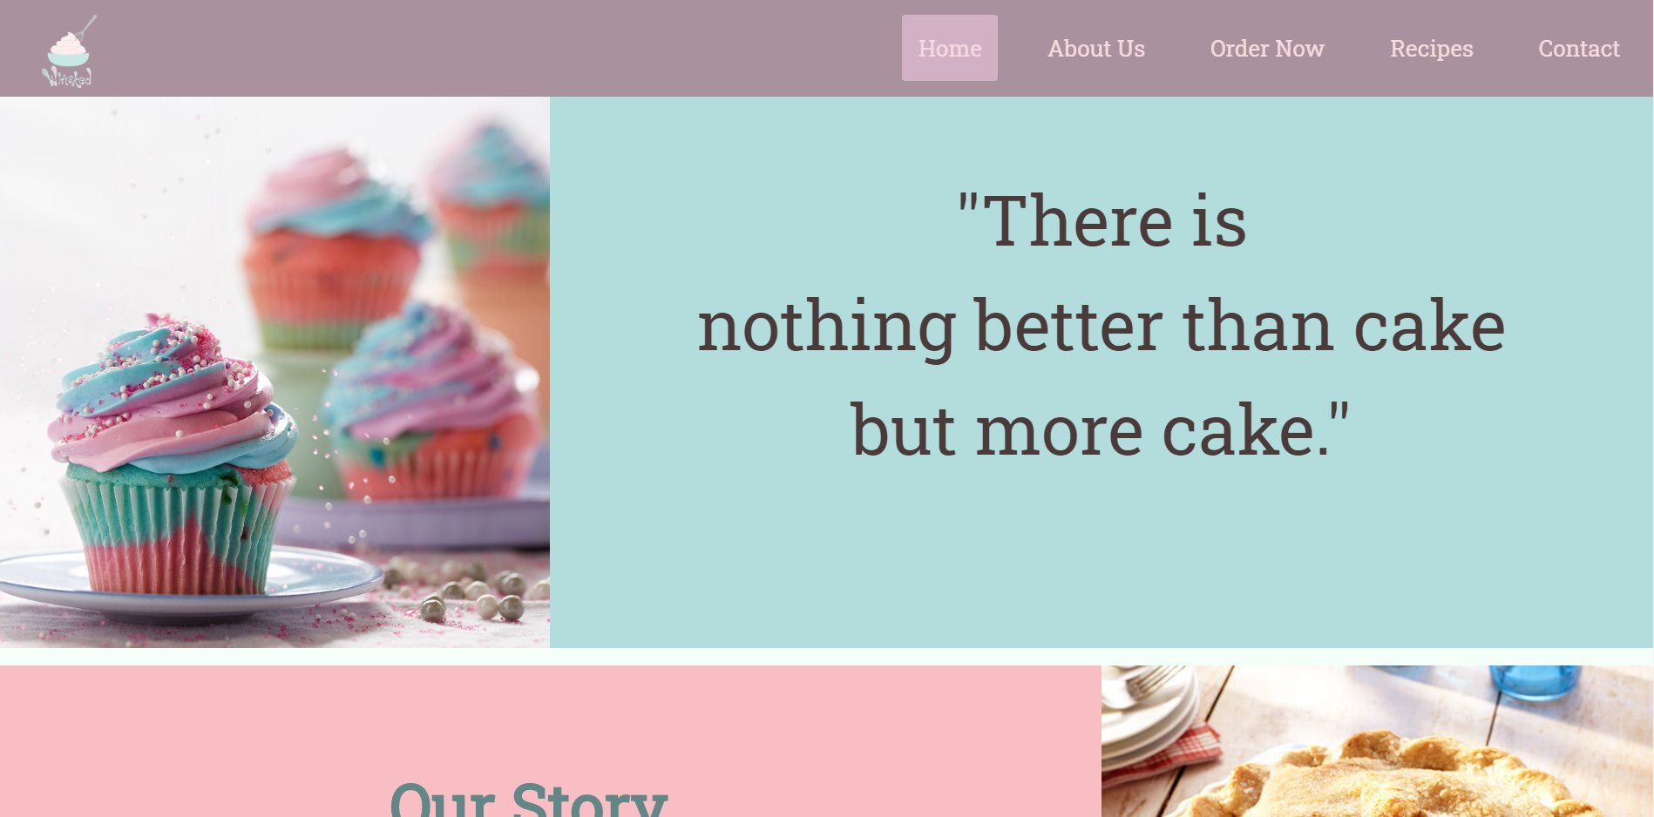

Figure 1: Screenshot of the index page

The main page contains a few icons in the last grid element to show the features offered by the enterprise. This element contains another grid to equally distribute each image and the respective box.

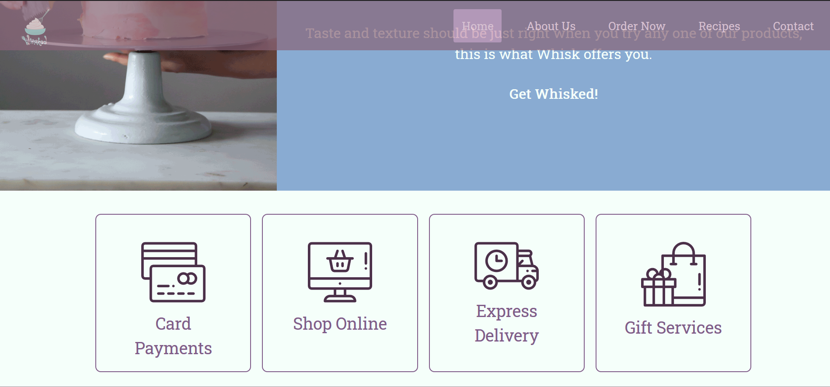

Figure 2: Screenshot of the icons grid element

The navigation bar was designed with the logo on the left and the menu list elements on the right. The navigation bar was made to be in a fixed position when the user scrolls through the web page. To let the user know that the page is not on the very beginning of the page, the author has made the navigation bar transparent.



Figure 3: Screenshot of the navigation bar

In the main page, a modal was used to get the rating and the comments section as a pop-up without directing the user to the contact page.

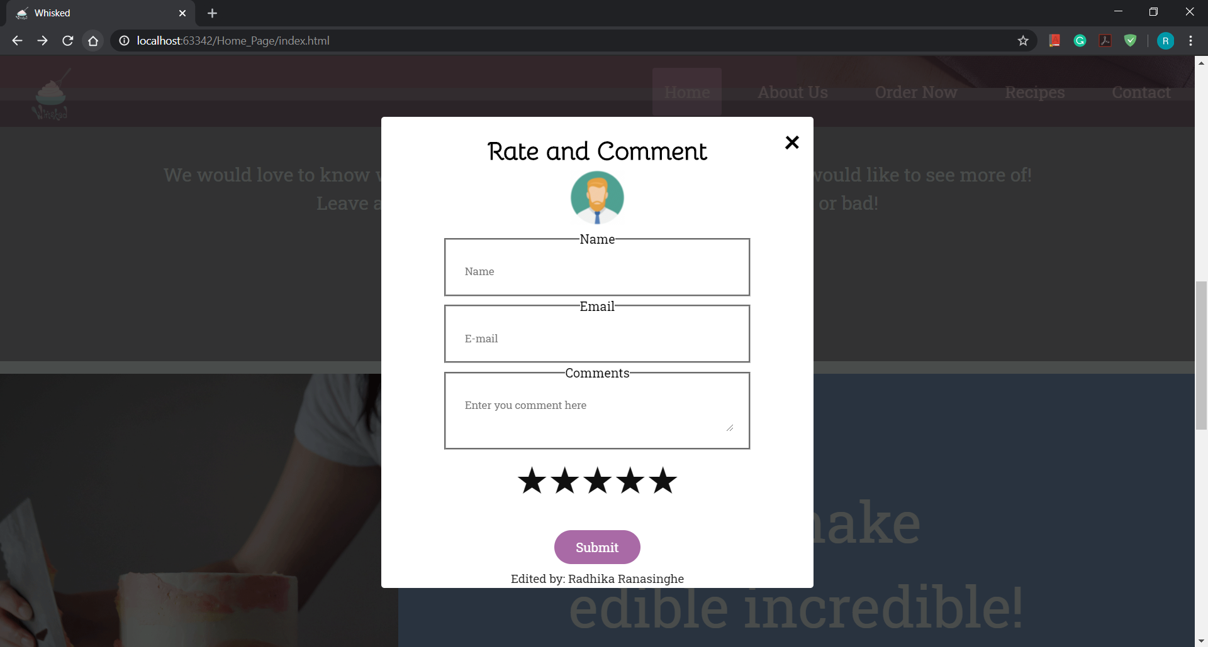

Figure 4: Screenshot of the Rate and Comment Modal

The footer was divided into 3 parts as left, center and right. The left side of the container has the logo and the content of the navigation bar. While the center of the container offers user to access contact details of the enterprise and the right of the container offers a description about the company and the name of the team member who edited the respective page.

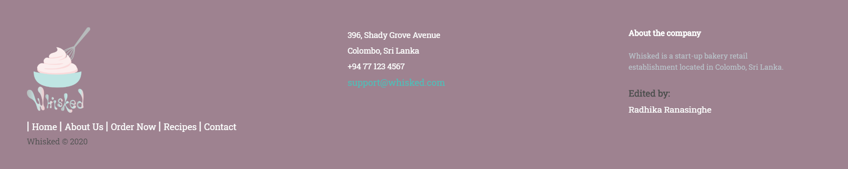

Figure 5: Screenshot of the footer

## The Individual Page (Recipes)

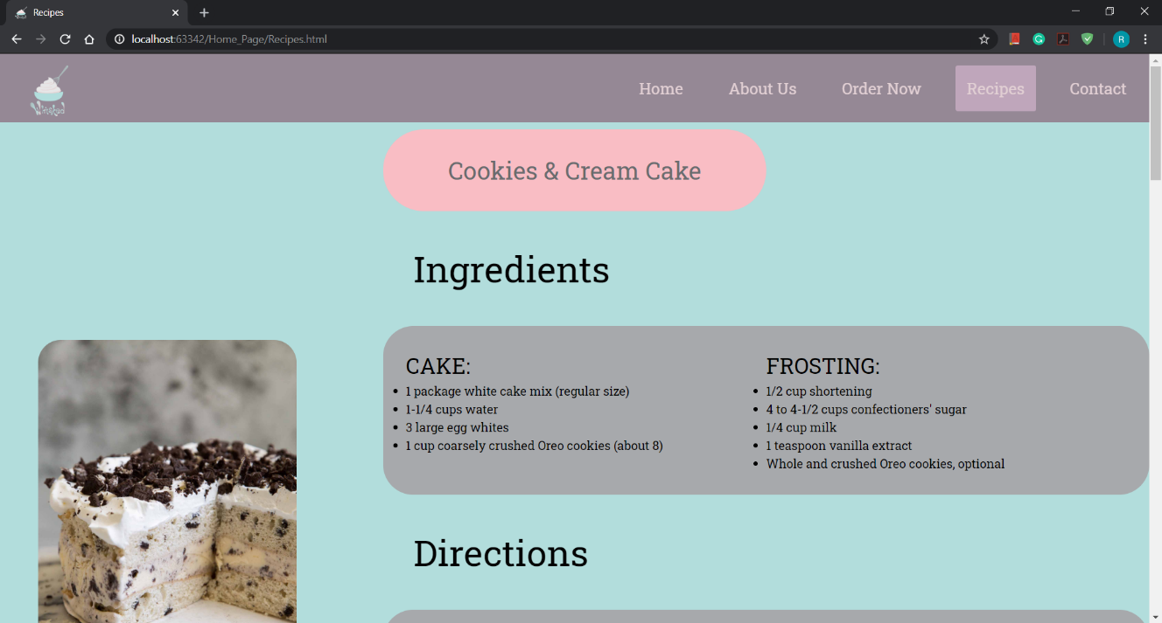The individual page done by the author was on the recipes of the baked goods offered by the enterprise. The layout was arranged through a grid. The page consists of three recipes which are linked to the navigation bar sub menu elements of the Recipes item in the main menu.

Figure 6: Screenshot of the Recipes (Cookies and Cream Cake)

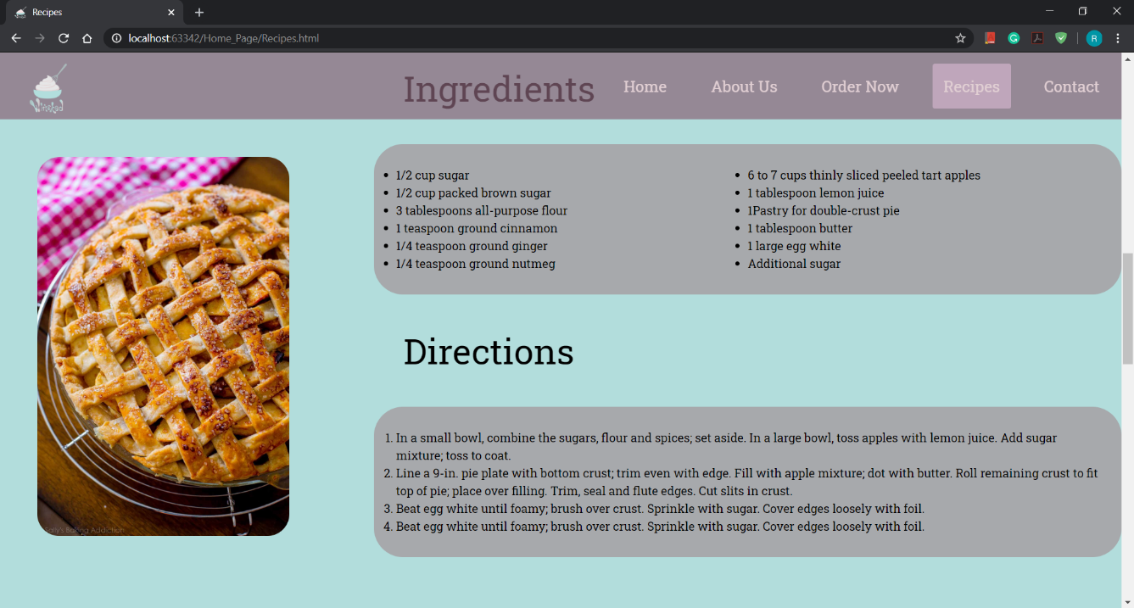

Figure 7: Screenshot of the Recipes page (Apple Pie)

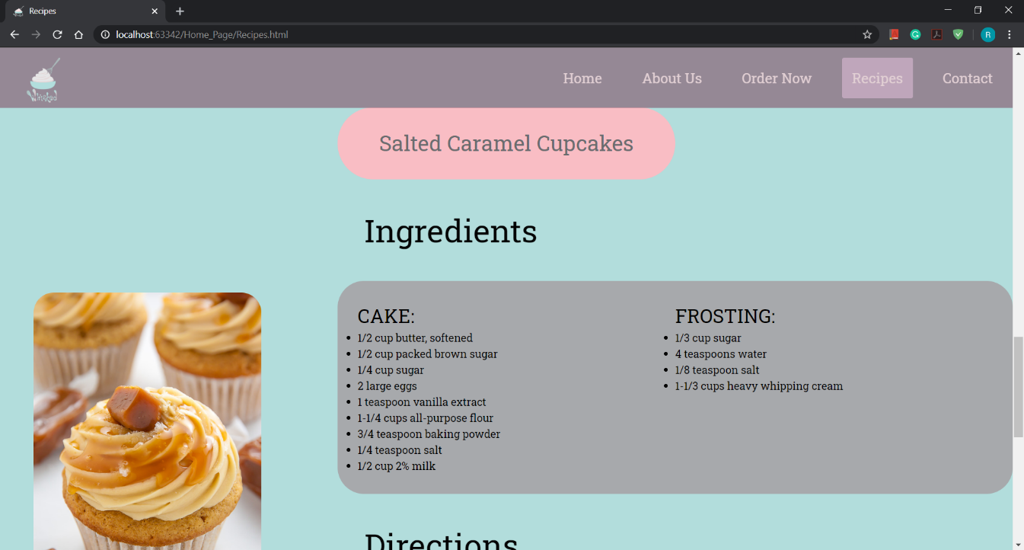

Figure 8: Screenshot of the Recipes page (Salted Caramel Cupcakes)

# Discussion of UI and application of UX principles

The webpages were designed according to a pastel color theme to compliment the main topic being bakery goods/cake items. Keeping in mind the above reasoning the logo was designed with a pastel color pallet.

## Information Architecture

### Design

Including the ‘index.html’ all the other HTML files were stored root folder while the CSS and JavaScript files were stored in their respective folders inside the root folder.

The Navigation and the Footer are common to all linked HTML files, after consideration of this factor, a separate CSS file was created including only the CSS properties that should be common to all HTML files. This way it is easier to connect this one CSS file rather than adding and repeating the same piece of coding to all style sheets.

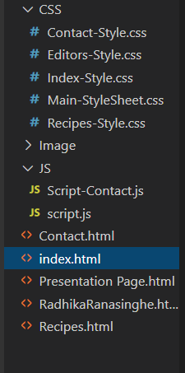

Figure 9: Screenshot of the Root Directory

To let user the locate where he/she is in the website, the author has used a different background color for the list element in the Navigation Bar. The author has used a class called ‘active-page’ which is updated in each HTML file. The navigation bar also allows the user to direct themselves to different parts of the same webpage without having to scroll up and down.

A snippet of the HTML code is as follows:

1. **<li** class="active-page"**><a** href="Recipes.html"**>**Recipes**</a>**
2. **<div** class="sub-menu-products"**>**
3. **<ul>**
4. **<li><a** href="Recipes.html#Cookies&Cream"**>**Cookies & Cream Cake**</a></li>**
5. **<li><a** href="Recipes.html#ApplePie"**>**Apple Pie**</a></li>**
6. **<li><a** href="Recipes.html#SaltedCaramel"**>**Salted Caramel Cupcakes**</a></li>**
7. **</ul>**
8. **</div>**
9. **</li>**

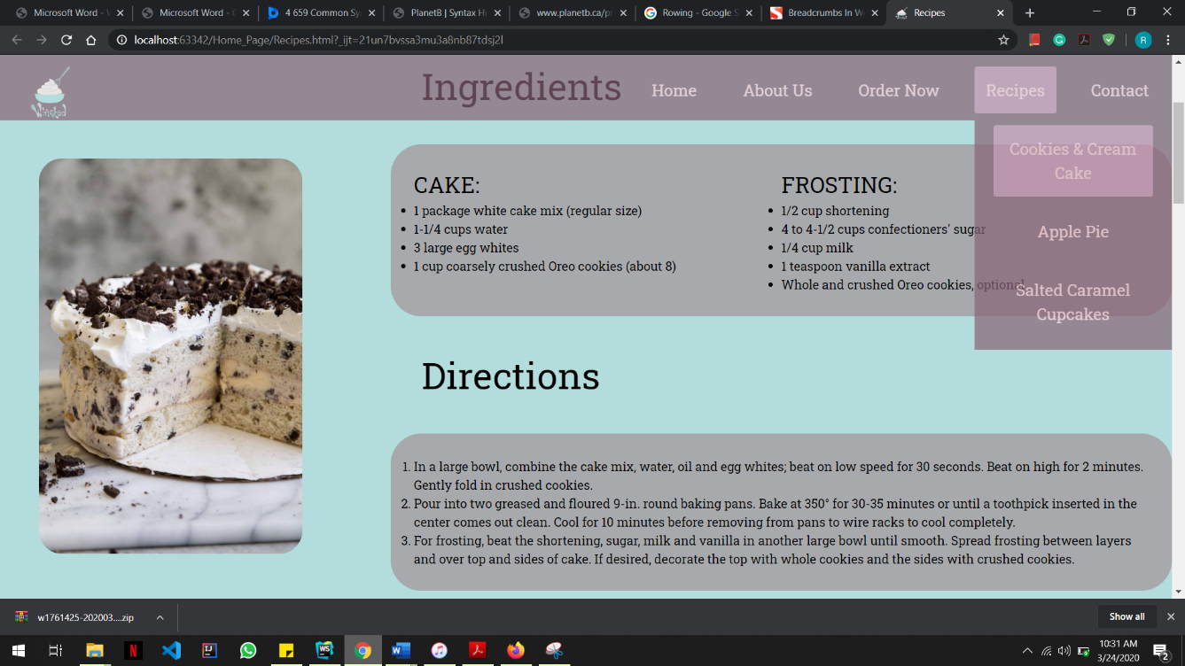

Figure 10: Screenshot of the 'Active-Page'

### Code to achieve good information architecture

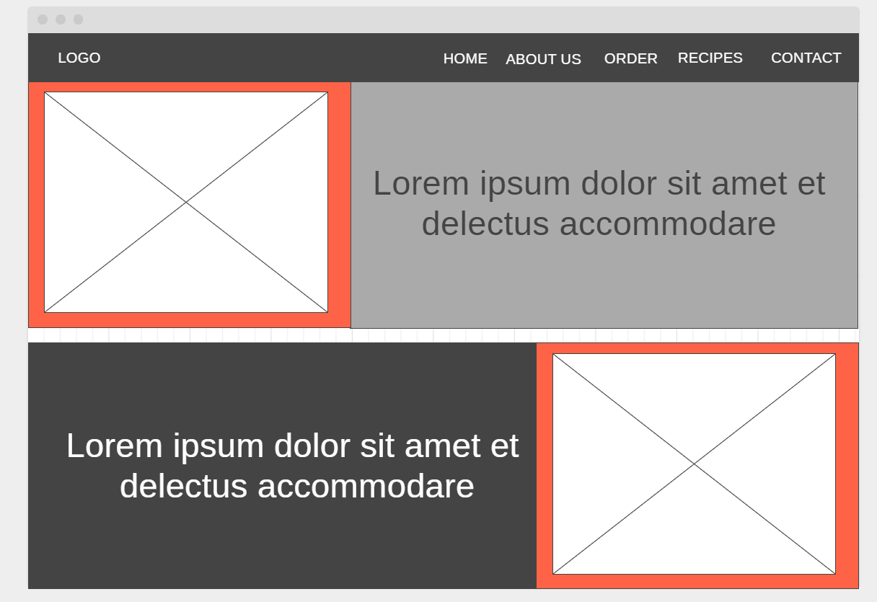The author was able to undergo the development process effortlessly without a hassle because the author started off the project with a farsighted view and made a wireframe. These wireframes made were real time-savers.

Figure 11: Wireframe made for the Main Page

## Color Balance/ Composition/ Graphics/ Consistency

### Design

For the user interface of this website, the author and the team chose a pastel color palette which they thought would connote the pops of flavor to the products they are selling.

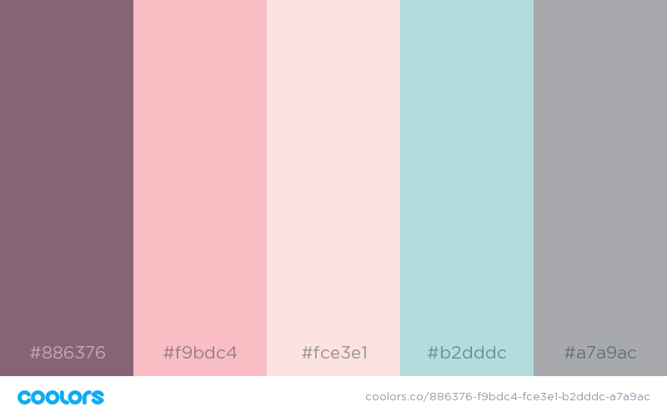

Figure 12: The Color Palette

The logo contains these colors which compliments the all the web pages in the site. Given below is the logo of the website.

Figure 13: The Logo of the enterprise

This color palette not only brings out the Elegance than other color palettes but also this awakens a feeling of sophistication and purity in one’s self. This website bringeth forth a minimalistic approach. The pastel colors convey a soft and friendly ambience to the viewer thus arousing calm feelings.

### Code to achieve a good color balance and ensure consistency

For a good color balance, while using this minimalistic color palette the author and the team were compelled to use a darker foreground color wherever possible when a pastel color was used as the background. The first row of the grid layout in the main page was checked upon a contrast test.

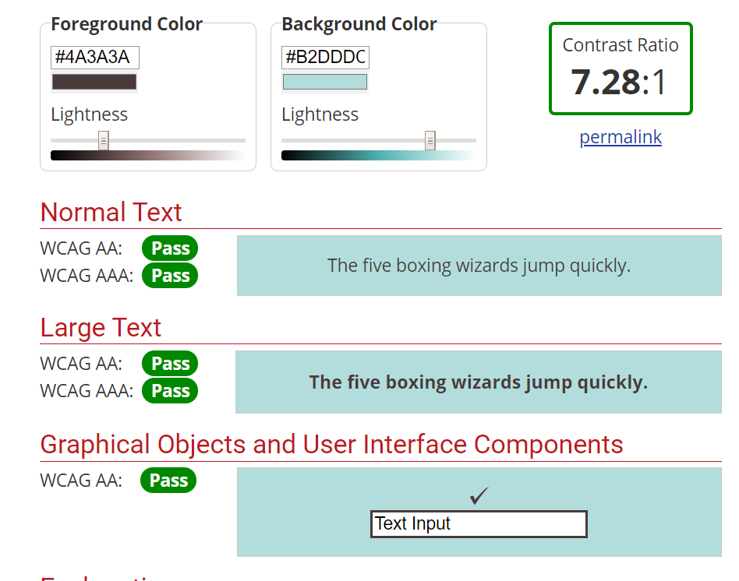WebAIM (<https://webaim.org/resources/contrastchecker/>) was used to obtain this.

Figure 14: Contrast Ratio of the Colors Selected

A snippet of the code as an example for where the contrast ratio was tried to maintain throughout the website:

1. .recipe-container{
2. **background**: #B2DDDC;
3. **color**: #101010;
4. **display**: grid;
5. grid-template-columns: 1fr 2fr;
6. grid-auto-rows: minmax(100px, auto);
7. justify-items: stretch;
8. align-items: stretch ;
9. }

## Typography/ Consistency

### Design

The typography always speaks to the viewer in a way that colors nor pictures does. When it comes to web design and development, the viewer should always have a clear idea as much as its breath-taking beauty or else the viewers might be confused and refuse to use the website. Using fonts in a clever manner assisted the authors in avoiding above mentioned situations.

The authors maintained a strict habit of using a typography hierarchy to convey messages to the viewers. The larger the font is the more attention will be sought by the viewer.

Figure 15: Screenshot of the main page as an example for typography hierarchy

### Code to achieve a good typography and ensure consistency

To accomplish this, author used only one font family throughout the website to ensure consistency. This web font was taken from Google Fonts.

A snippet of the link added to the HTML code and CSS code:

**<link** href="https://fonts.googleapis.com/css?family=Roboto+Slab&display=swap" rel="stylesheet"**>**

1. *{
2. **font-family**: 'Roboto Slab', serif;
3. **line-height**: 1.4;
4. **padding**: 0;
5. **margin**: 0;
6. box-sizing: border-box;
7. }

## Gestalt Principles of Grouping

The Gestalt Principles of Grouping was majorly used by the author to catch the viewer’s eye in the website as a larger picture, so the user/ viewer immediately has an optimistic mind about the website.

The Law of Proximity:

Regularity was maintained by sorting items smaller elements of the same variety into a larger shape to form a pattern. As an example, in the Recipes Page the Ingredients and the Directions were grouped and given a separate background color. The Ingredients are further grouped into smaller elements.

The Law of Similarity:

Similarity was maintained by seeking differences and similarities and grouped similar elements. As an example, in the main page the feature offered by the enterprise is grouped with their icons and the text inside a box and brought closer together with equal spacing and padding, also the same colors are used.

Authors sought the balance and order in all elements of the web page.

Figure 16: Screenshot of the Recipes Page (Evidence for Gestalt Grouping)

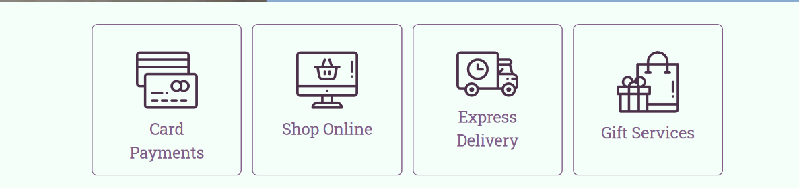

Figure 17: Screenshot of the Main Page (Evidence for Gestalt Grouping)

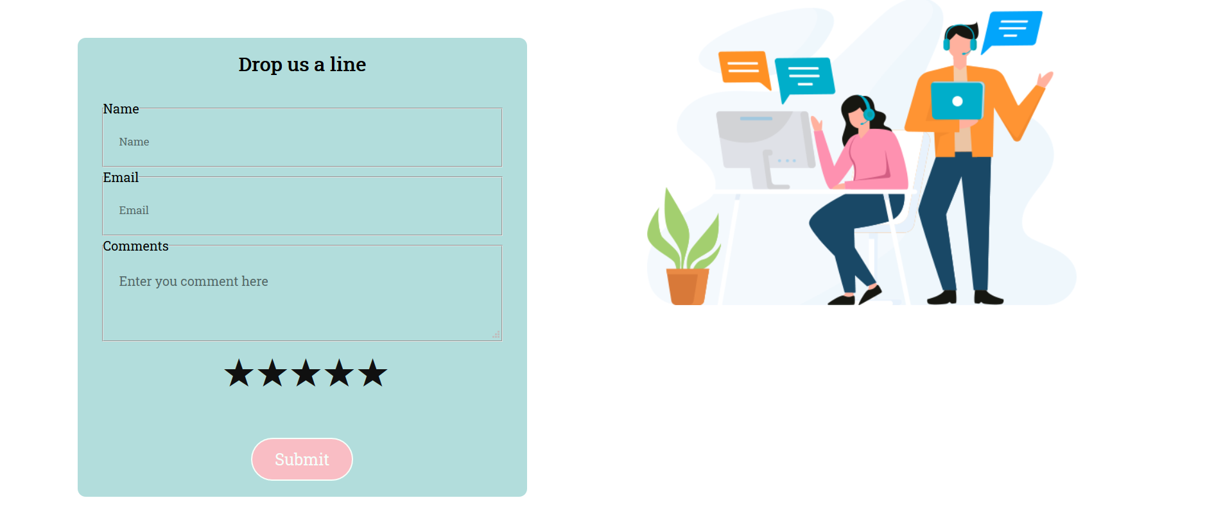

Figure 18: Screenshot of the Contact Page (Evidence for Gestalt Grouping)

## Accessibility (Graphics/ Forms)

### Graphical Elements (Design/ Code)

In the event where the images could not be loaded into the web page, alt tags were used by the author to knowledge the viewer a descriptive tag of what content is there to be loaded.

A snippet of the HTML code:

1. **<div** class="wrapper"**>**
2. **<img** class="box1" src="Image/cupcake.jpeg" alt="Image of a cupcake"**>**
3. **<div** class="box2"**>**
4. "There is**<br>**nothing better than cake**<br>**but more cake."
5. **</div>**
6. **<div** class="box3"**>**
7. **<div** class="our-story"**>**
8. **<h1** class="our-story"**>** Our Story...**</h1>**
9. **</div>**
10. All our cakes and pies are made from our favorite recipes collected over time from friends and family.**<br>**
11. Read more about our story....
12. **<div>**
13. **<button** type="button" class="button-read-more"**><span>**Read More**</span></button>**
14. **</div>**
15. **</div>**
16. **<img** class="box4" src="Image/pie2.jpg" alt="Image of an apple pie" **>**

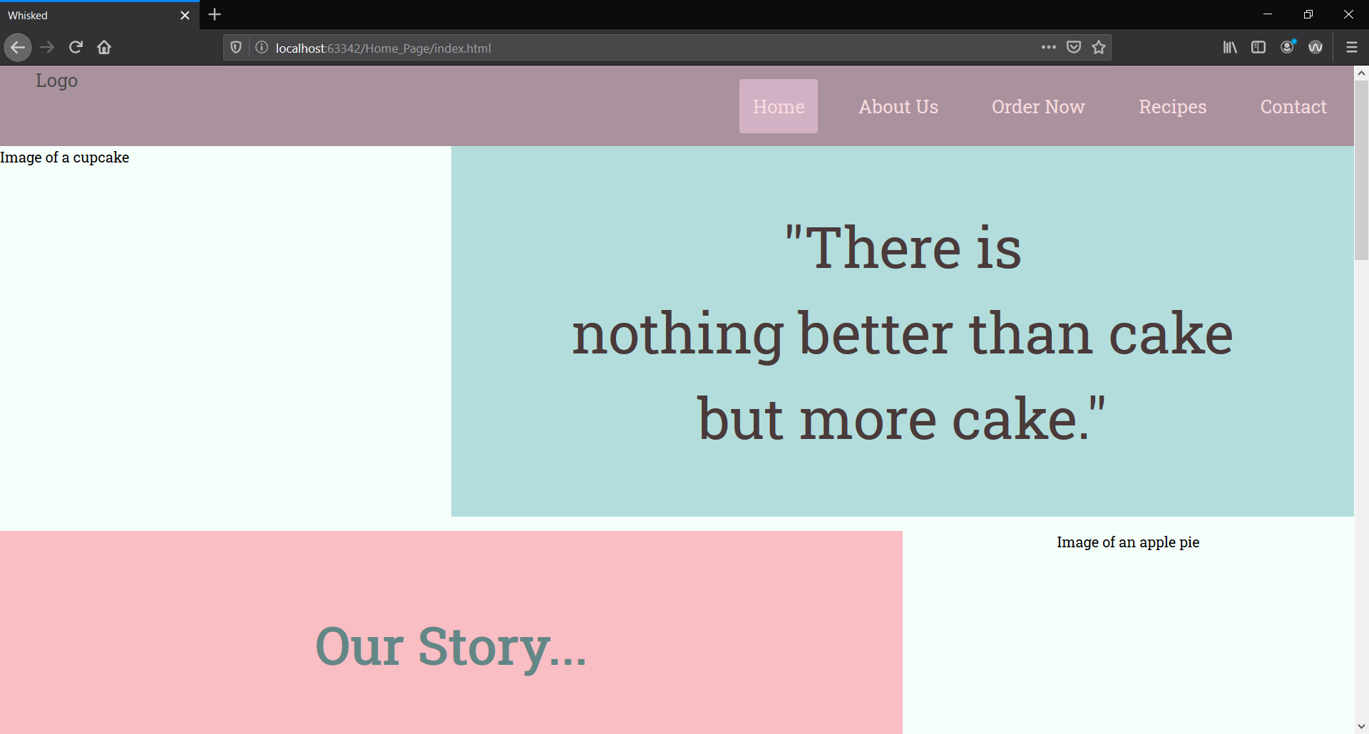

Figure 19: Screenshot of the Main Page without Images

### Form Elements (Design/ Code)

Author has used placeholders in the event where user/ viewer needs assistance with which information goes where in the text input fields.

A snippet of the HTML code:

1. **<div** class="comment-fields"**>**
2. **<fieldset** class="inputFields"**>**
3. **<legend><label** for="name"**>**Name**</label></legend>**
4. **<input** type="text" name="name" id="name" placeholder="Ex: John Doe" class="comment"**>**
5. **</fieldset>**
6. **<fieldset** class="inputFields"**>**
7. **<legend><label** for="email"**>**Email**</label></legend>**
8. **<input** type="text" name="inputEmail" id="email" placeholder="example@example.com" class="comment"**>**
9. **</fieldset>**
10. **<fieldset** class="inputFields"**>**
11. **<legend><label** for="comment"**>**Comments**</label></legend>**
12. **<textarea** id="comment" name="comment" placeholder="Enter you comment here" class="comment"**>**

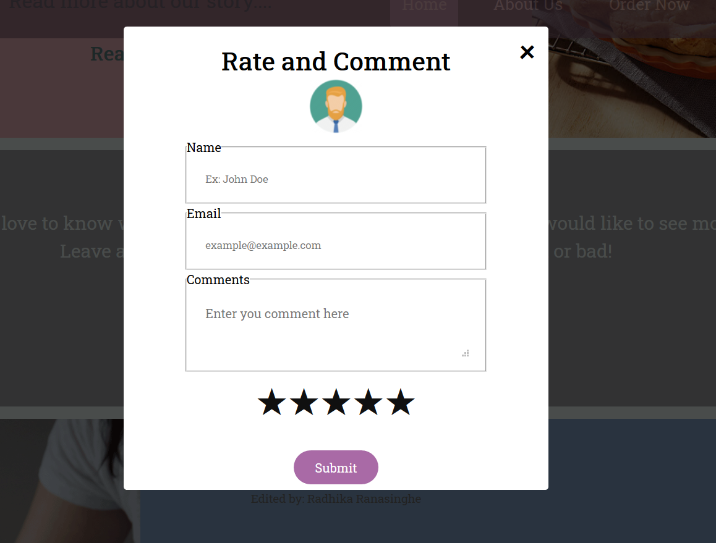

Figure 20: Screenshot of the Modal with placeholders in the form

## Error Prevention and Recovery

### Design

As mentioned in the above topics JavaScript validation was used to prevent the user from entering invalid data.

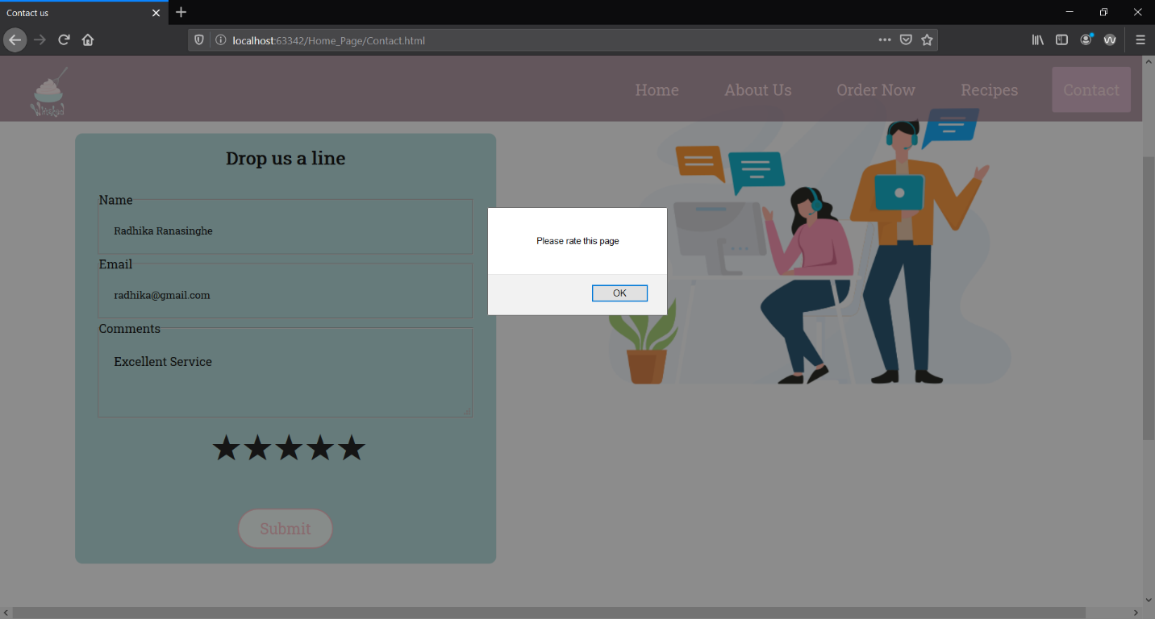

Figure 21:Screenshot of the alert when rating is not checked

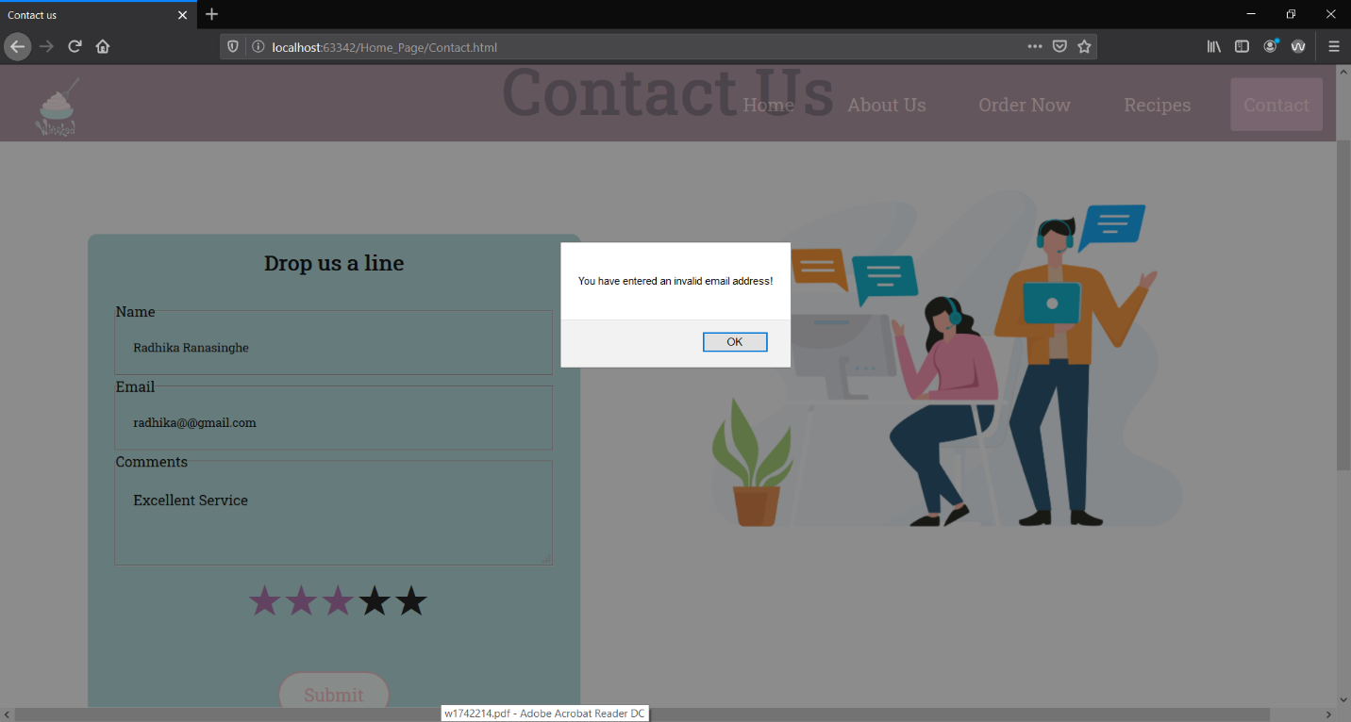

Figure 22: Screenshot of the alert when an invalid e-mail address is entered

### Code to address error prevention and recovery

1. //form validation
2. **function** form_validation(){
3. check_rating();
4. ValidateEmail();
5. **if** (name === "" || name == **null**){
6. alert("Please insert your Name")
7. }
8. **else** **if** (email === "" || email == **null**){
9. alert("Please insert your e-mail")
10. }
11. **else** **if** (correct_email === "no"){
12. alert("You have entered an invalid email address!")
13. }
14. **else** **if** (comment === "" || comment == **null**){
15. alert("Please type a comment")
16. }
17. **else** **if** (user_rating === "" || user_rating == **null**){
18. alert("Please rate this page")
19. }**else**{
20. successfulComment();
21. }
22. }
23. // checking rating
24. **function** check_rating(){
25. **if** (document.getElementById("star1").checked){
26. user_rating = "1 Star"
27. }
28. **else** **if** (document.getElementById("star2").checked){
29. user_rating = "2 Stars"
30. }
31. **else** **if** (document.getElementById("star3").checked){
32. user_rating = "3 Stars"
33. }
34. **else** **if** (document.getElementById("star4").checked){
35. user_rating = "4 Stars"
36. }
37. **else** **if** (document.getElementById("star5").checked){
38. user_rating = "5 Stars"
39. }
40. }
41. //email validation
42. **function** ValidateEmail() {
43. **if** ((/^\w+([\.-]?\w+)*@\w+([\.-]?\w+)*(\.\w{2,3})+$/).test(email.value)){
44. correct_email = "yes"
45. }
46. **else**{
47. correct_email = "no"
48. }
49. }
51. **function** resettingFields() {
52. star1.checked = **false**;
53. star2.checked = **false**;
54. star3.checked = **false**;
55. star4.checked = **false**;
56. star5.checked = **false**;
58. name.value = "";
59. email.value = "";
60. comment.value = "";
61. }

# Janet Regulations

In the event of developing this website the author has abide by the Janet Regulations and the website was constructed with the sole objective of addressing the academic work. The website is not subjected to any illegal nor unethical activities. Creation or transmission of any hostile data, obscene or indecent graphical content, data nor any similar content was not used in the process of building this website. Neither does this website contain any malicious software nor the authors are willing to violate the privacy of any user of the website.

# Conclusion

This assignment was taken as an opportunity by the author to excel their skills in time management, teamwork, communication skills while enlightening themselves with the web design and development skills and UI/UX designing. The assignment required the team to refer, learn and implement many unknown technologies/ web development properties.

Through ups and downs author has managed to complete all of the tasks required to be done by the Student 2 role.

# References

W3schools.com. 2020. *How To Animate Buttons With CSS*. [online] Available at: <https://www.w3schools.com/howto/howto_css_animate_buttons.asp> [Accessed March 2020].

W3schools.com. 2020. *How To Create A Contact Form With CSS*. [online] Available at: <https://www.w3schools.com/howto/howto_css_contact_form.asp> [Accessed March 2020].

# Appendices

## Appendix A (Code)

## Appendix B (Screenshots)

## Appendix C (Individual Statement)

|  |  |  |  |
| --- | --- | --- | --- |
| Student Name: | Radhika Ranasinghe | Student Id: | 2018199/ w1761764 |
| State what tasks you carried out in the project. | | | |
| The tasks carried out were:  -The main page  -The Comments and Rate section with JavaScript validation  -The individual page (Recipes) | | | |
| State what you enjoyed and did not enjoy about teamwork. | | | |
| Personally, enjoyed designing the content of the web page and working as a team. | | | |
| State what you learnt about teamwork. | | | |
| Trusting the team members with their opinions and co-operation. | | | |
| State what skills you gained/learnt from undertaking the project. | | | |
| About the UI/UX principle in depth and gained co-operation skills. | | | |
| State any strengths about yourself that emerged whilst undertaking the project. | | | |
| My co-ordination with the team members was a strength when putting the website together. | | | |
| State any weaknesses about yourself that emerged whilst undertaking the project. | | | |
| Time management skills has to be improved. | | | |
| State how you would do things better if you were to undertake the project again. | | | |
| Better preparation before the project initialization. | | | |
| Additional general or project specific comments: | | | |
|  | | | |
| Student Signature: |  | Date: | 24th of March 2020 |